**AWS CODE DEPLOY**

https://github.com/vishwanathacharya/codedeploy-to-ec2-nodejs.git

Open AWS Management Console

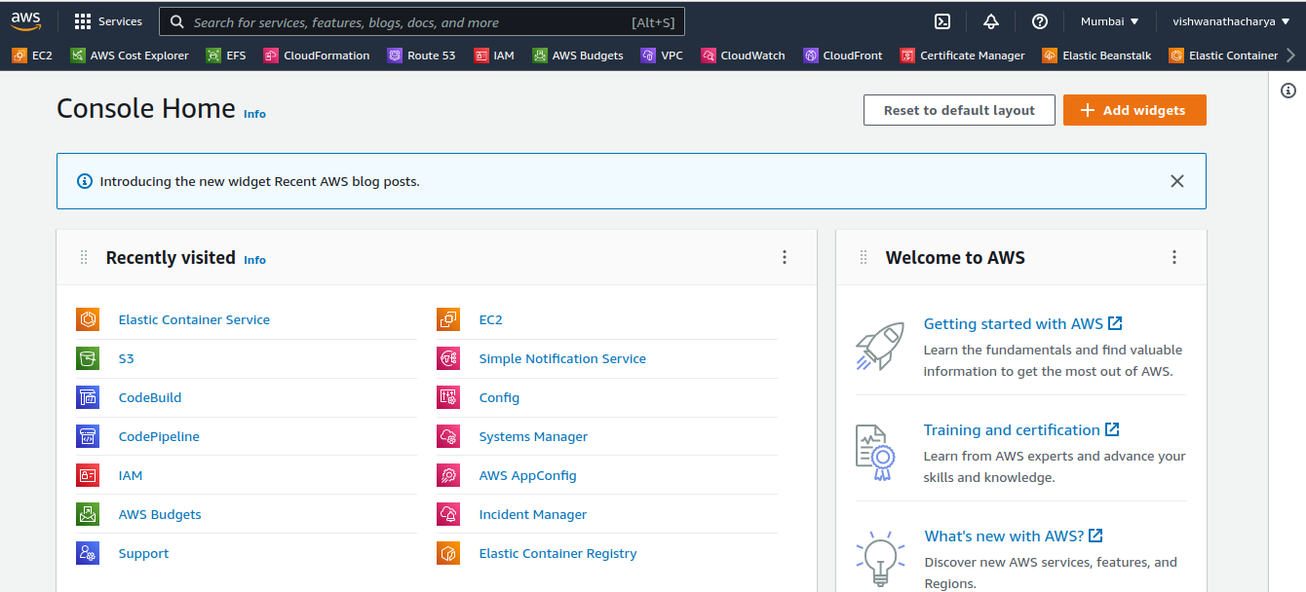

Search IAM Service for Create Role

1- Create Role For EC2 Instance

2- Create Role For Code Deploy

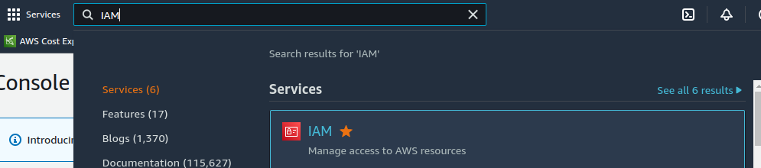

Open IAM Service

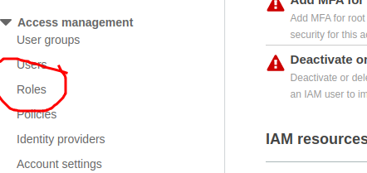

Left hand search Roles

Click on Roles

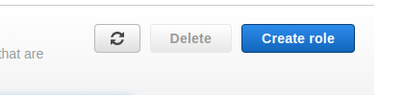

Create Role

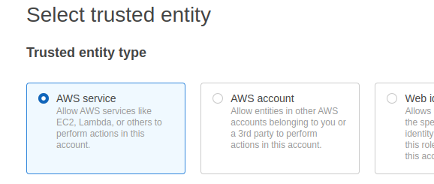

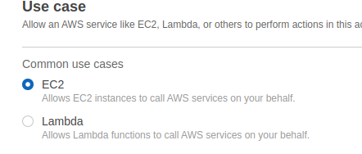



add policy on Role

Administetoreaccess

Awss3fullaccess

Awscodedeployfullaccess

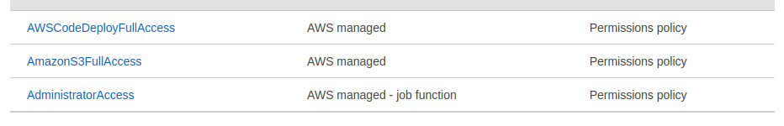



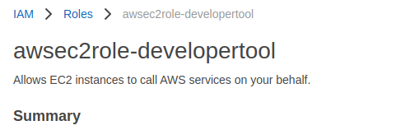

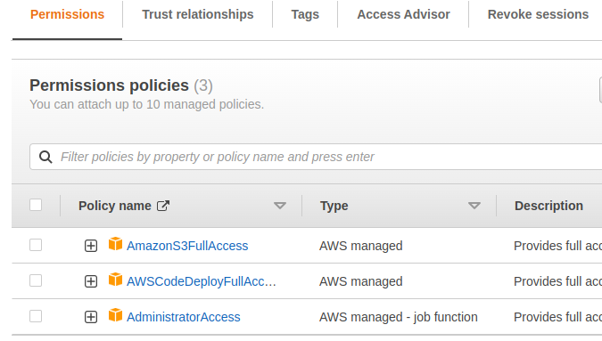

Create Another Role for CodeDeploy

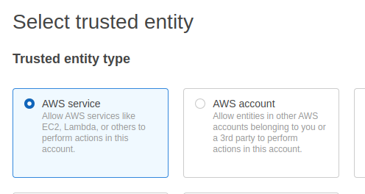

Choose use Cases and Search CodeDeploy

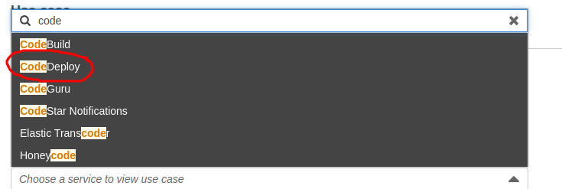



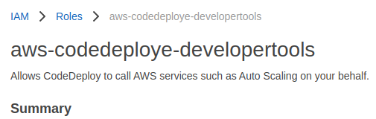



Create instance with ec2 role with script

| #!/bin/bash |  |
| --- | --- |
|  | sudo apt-get -y update |
|  |  |
|  | # INSTALL NODEJS - ONLY FOR UBUNTU |
|  | sudo apt install nodejs -y |
|  |  |
|  | # INSTALL NPM & PM2 - ONLY FOR UBUNTU |
|  | sudo apt install npm -y |
|  | sudo npm install pm2@latest -g |



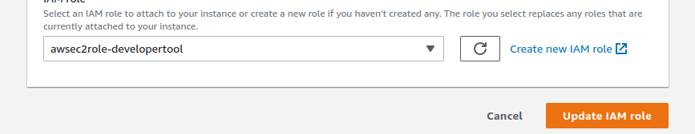

Open AWS CodeDeploy Service

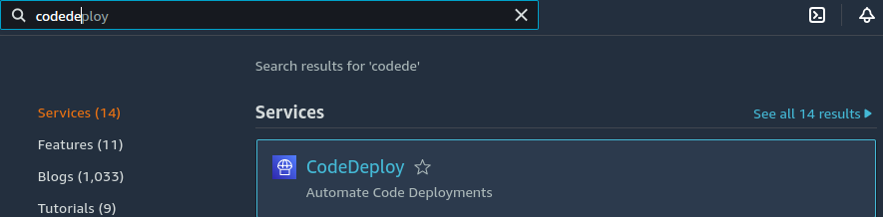

Open codeDeploy

Create Application

On premises

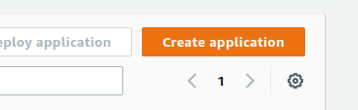

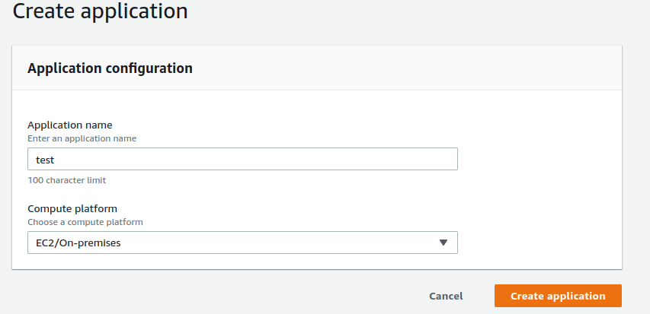

Create Deployment Group

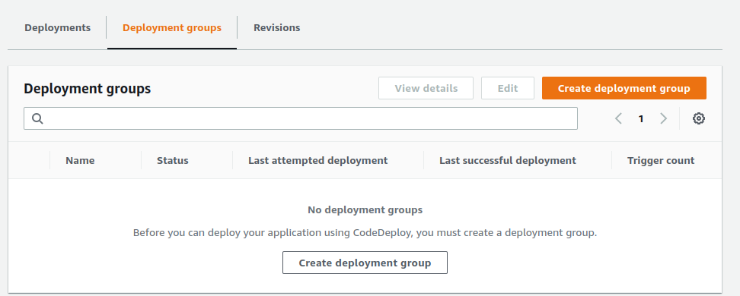

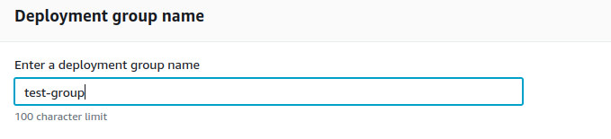

Choose your AWS-CodeDeploy Role

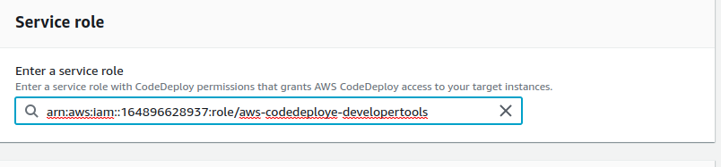

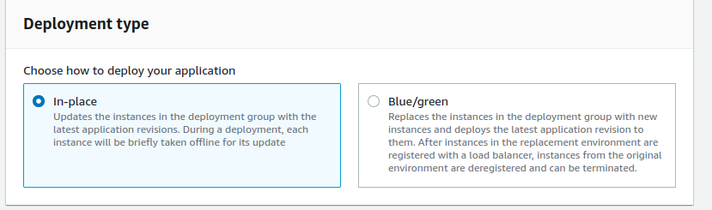

Choose which ec2 instance you want

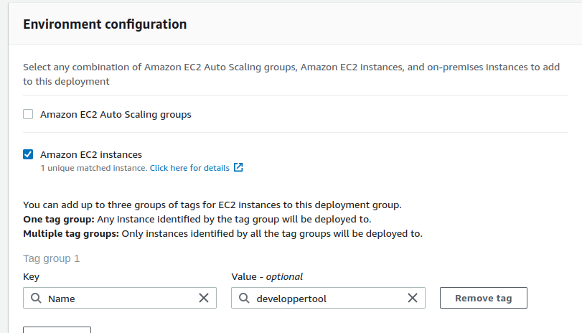



Open aws codepipiline

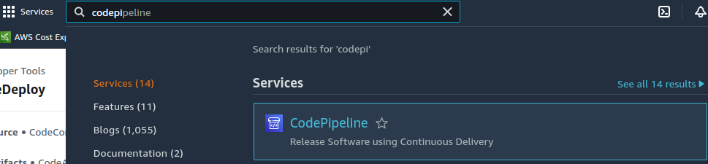

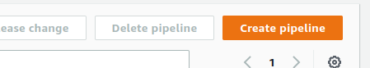

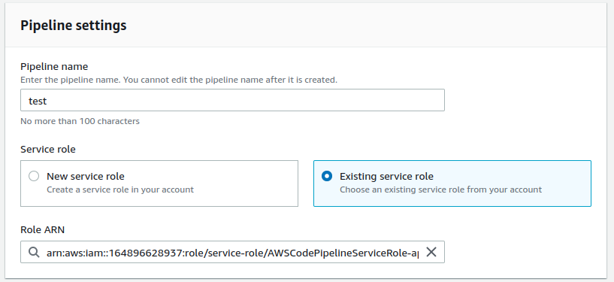

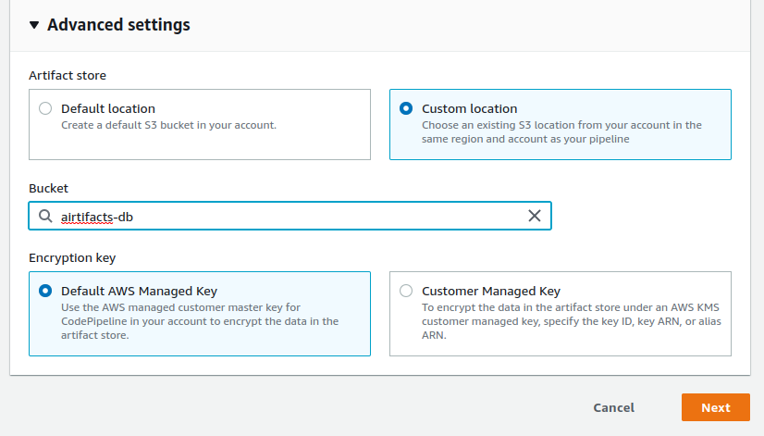

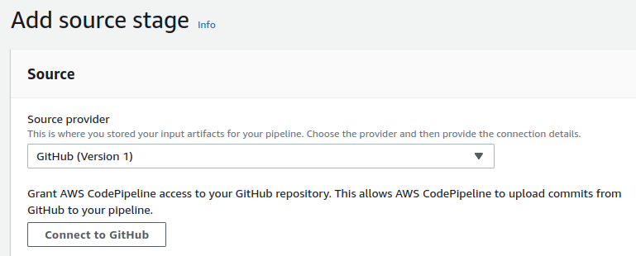

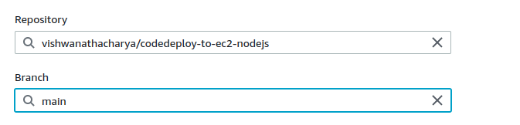

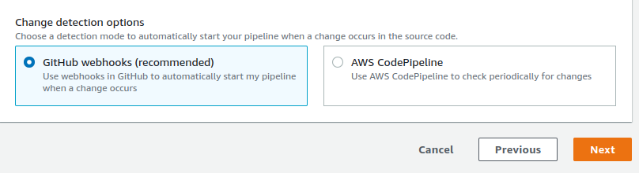

Skip build stage

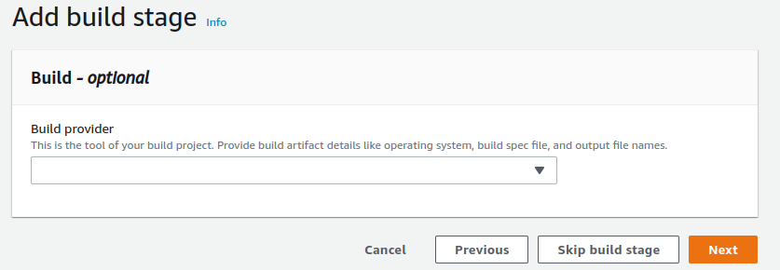

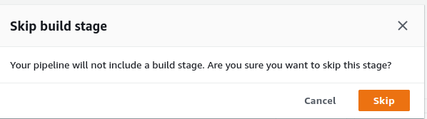

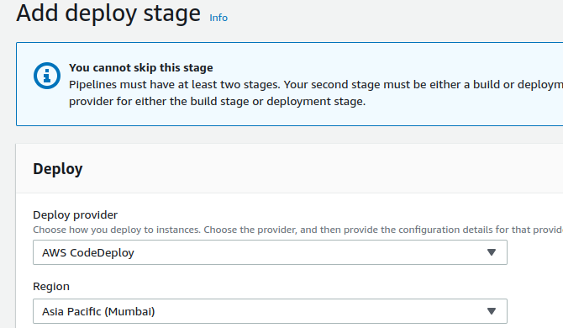

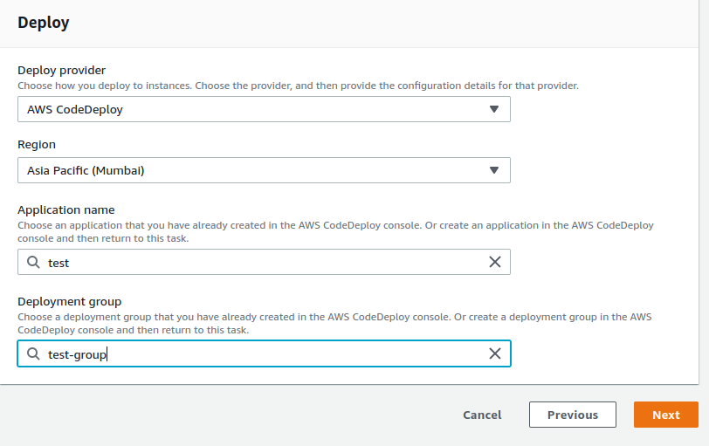

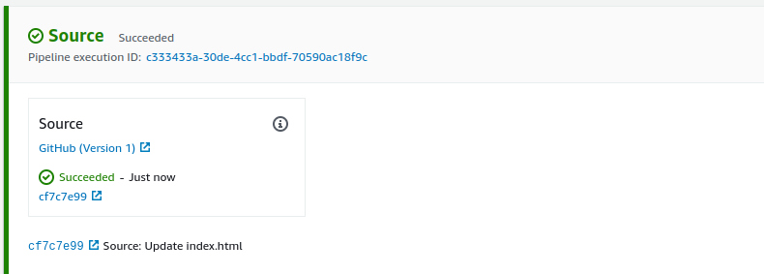

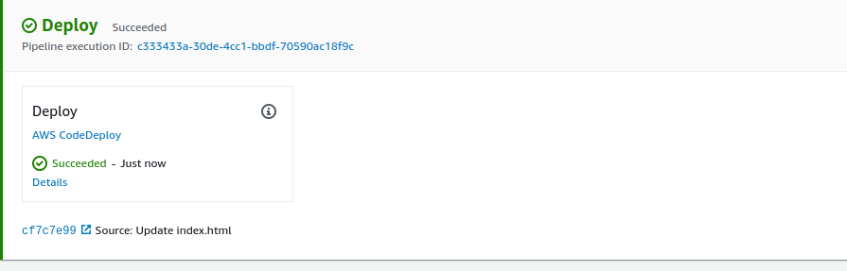

http://13.232.2.32:3000/